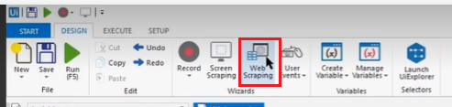

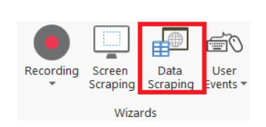

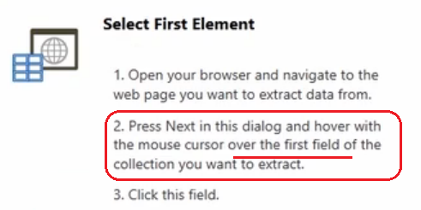

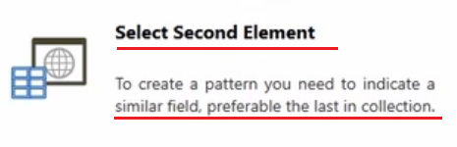

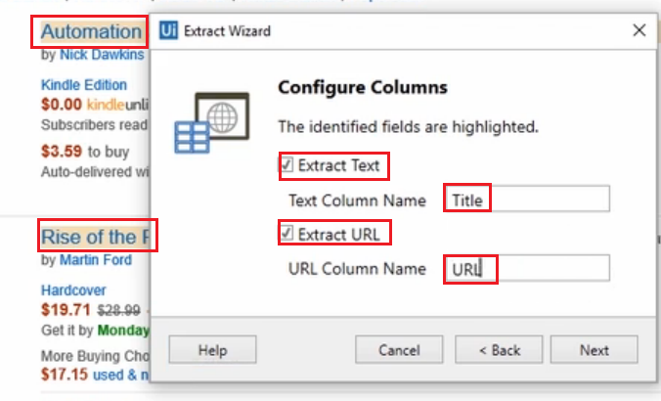

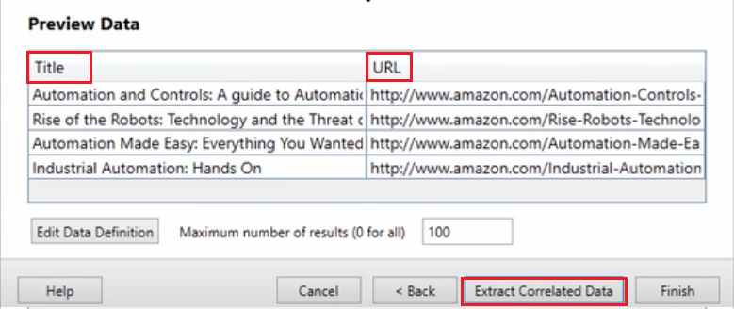

Extract the other fields : **Extract Correlated Data**

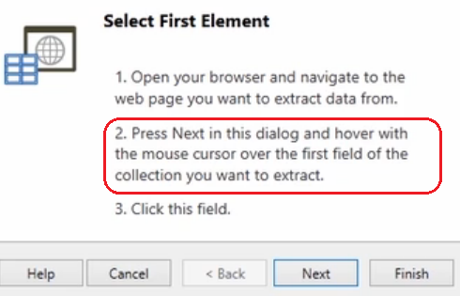

This time we only want the text, not the URL

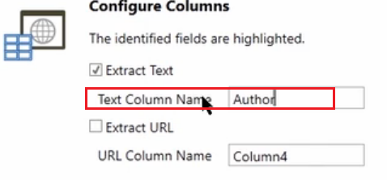

Do also with price

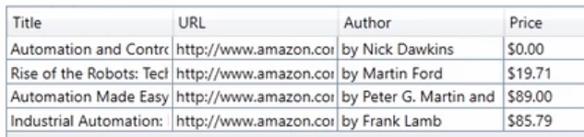

After clicking finish

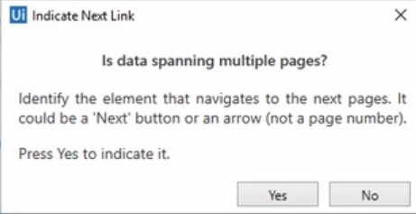

Because the page has more links, we click **YES**, and then we select the “**Next**” button on the web page that shows more links.

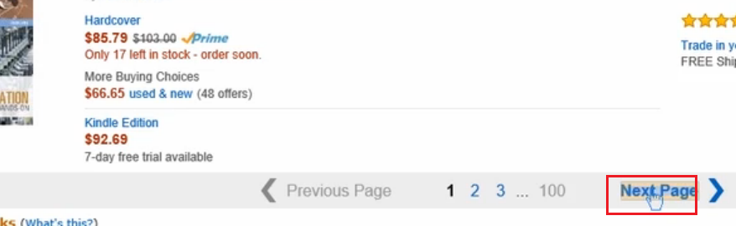

Create a CSV file with the info

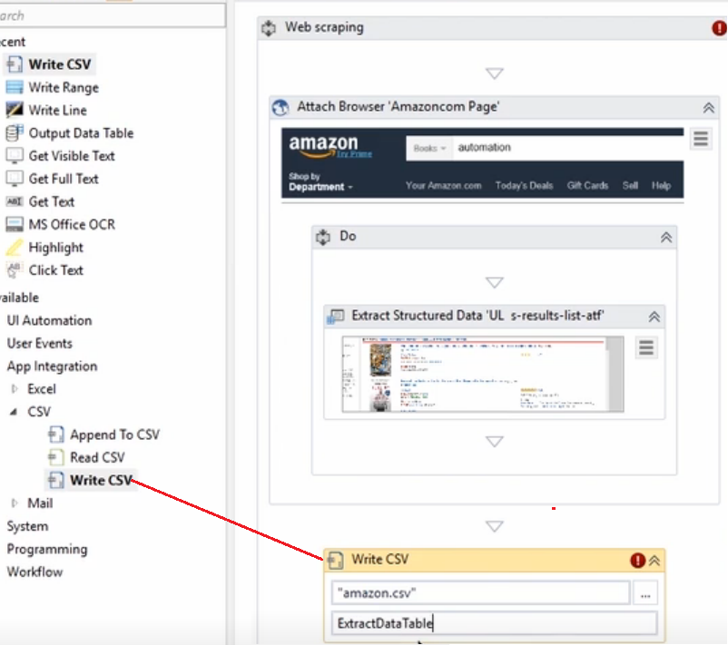

Set the name of the file and the information is in the output variable “ExtractDataTable”

**IMPORTANT, the ExtractData sets that the Maximun Number Of Results is 100, !!!!!**

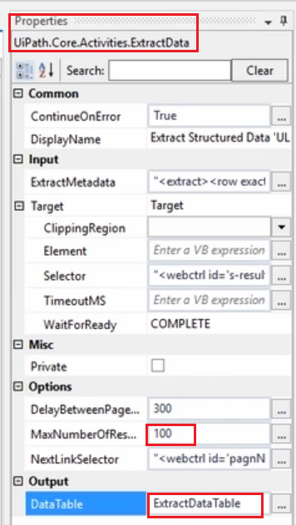

En el caso de cargar una matrix tabular



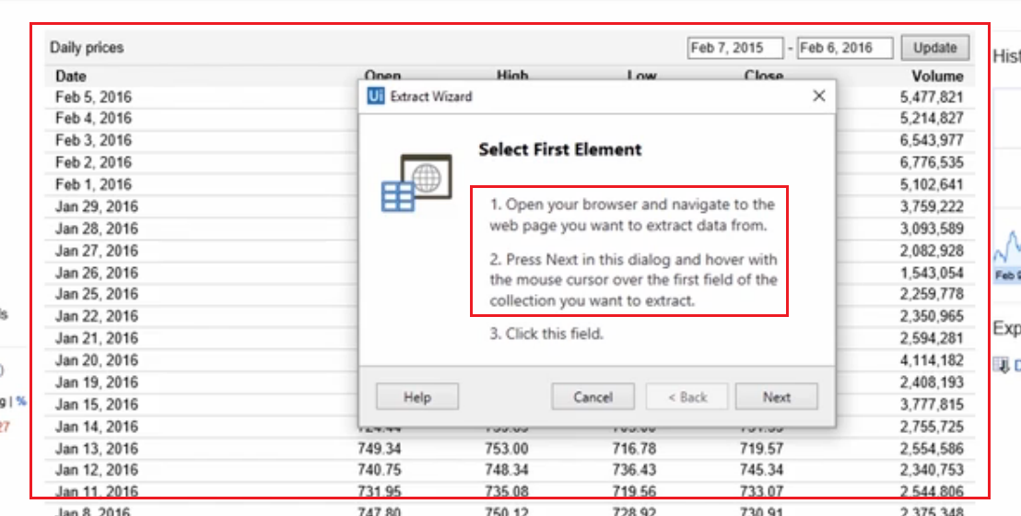

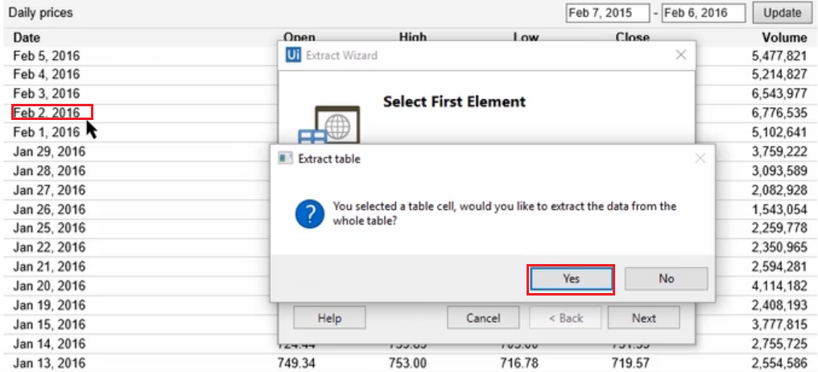

Click YES and it will extract the whole table, if you click NO you will have to go one by one

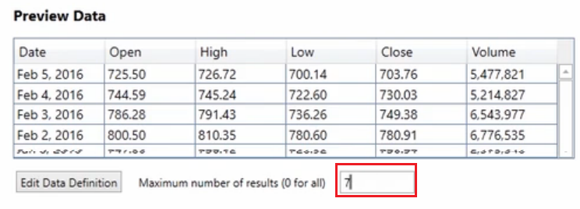

Para escribir los datos en una hoja de **cálculo Excel**, debe utilizarse la actividad **Write Range**.

* **Write Range** debajo del contenedor **Attach Browser** pero dentro del contenedor **Data Scraping**

